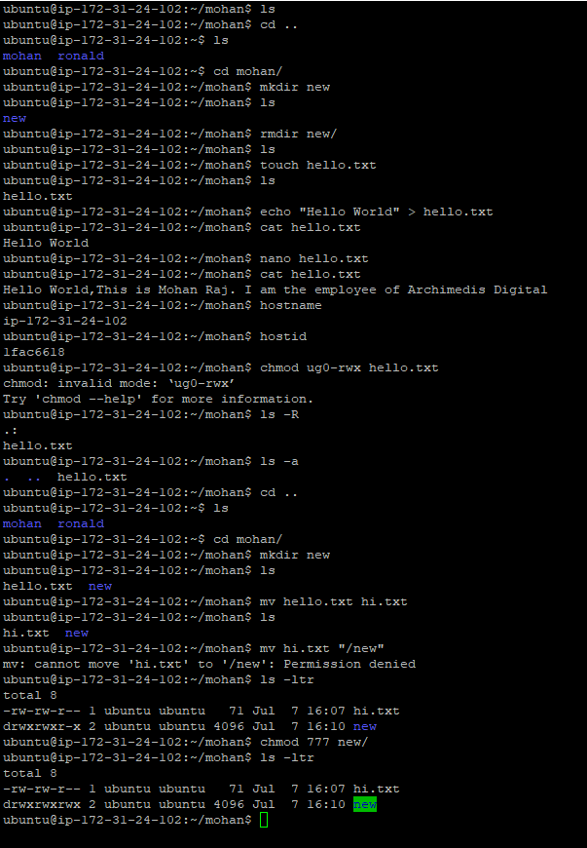

**Commands: ls, cd, mkdir, rmdir, echo, nano, cat, hosted, ls -R, ls -a, cd ..,mv, ls -ltr, chmod 777 filename, history, cal , date, sudo, whoami, ps, pwd, whereis aprops, top,**

**du -sh, du -ah, du-h.**

